Prediction Result

Machine Learning

Database

Scan

Camera

Palm

Hasil Pengenalan Palm Vein

Evaluasi Performa

Model SVM

Pengenalan Palm Vein

Ekstraksi Fitur CNN

Klasifikasi SVM

Ekstraksi Fitur CNN

Data Latih

Data Uji

Preprocessing Data

Data Palm Vein

Resize Image

Citra hasil Preprocessing

Subtract Image

Adjust Intensity

Rotate Image

Data Palm Vein

Image Closing

Adaptive Histogram Equalization

Adaptive Noise Removal

ROI Detection (Inner Border Tracing)

Median Filter

Anisotropic Diffusion Filter

Grayscale

(d)

(c)

(b)

(a)

ROI Palm Vein

Cropping Image

Kemiringan P1 dan P2

Mencari titik P1 dan titik P2

Mencari titik puncak dan titik lembah

Distance Distribution Diagram

Pixel Coordinate

Palm Vein Image

Edge Detection (Inner Border Tracing)

Morphology Opening (Smoothing)

Rotate Image ${90}^{o}$

Grayscale Image

Otsu Thresholding (Binary)

Morphology Opening (Smoothing)

Augmentasi Palm Vein

Augmentasi Image

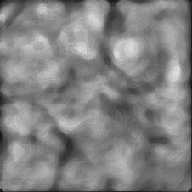 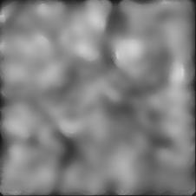

(c)

(b)

(a)

Convolutional 11 x 11 96 features map

Citra Palm Vein

Citra Palm Vein

Softmax

Dropout 0.4

Fully Connected 1000

Dropout 0.4

Fully Connected 4096

Dropout 0.4

Fully Connected 4096

Flatten

Max Pooling 2x2

Convolutional 3 x 3 256 features map

Convolutional 3 x 3 384 features map

Convolutional 3 x 3 384 features map

Max Pooling 2x2

Convolutional 11 x 11 256 features map

Max Pooling 2x2

Max Pooling 2x2

Citra Palm Vein

Convolutional 11 x 11 96 features map

Convolutional 3 x 3 384 features map

Convolutional 11 x 11 256 features map

Max Pooling 2x2

Dropout 0.4

Softmax

Citra Palm Vein

Fully Connected 1000

Dropout 0.4

Fully Connected 4096

Dropout 0.4

Flatten

Fully Connected 4096

Max Pooling 2x2

Convolutional 3 x 3 256 features map

Convolutional 3 x 3 384 features map